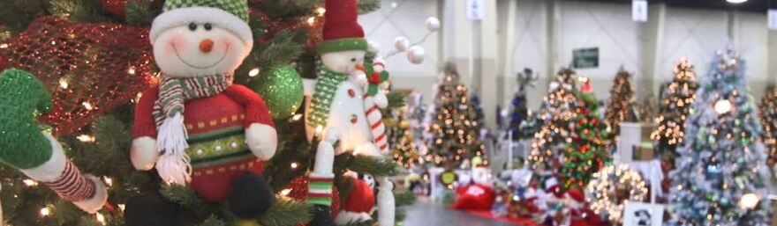
Corporate Sponsorship Information – Donation of a tree + $200
- Your business will be printed in the digital program as it appears on your registration form
- We will provide signage that bears your name or company name, tree title, and town
- You will receive acknowledgment of your donation, 4 free tickets to our “preview party” and announcements on our social media.
- You can choose to just sponsor the event for $200. Or you can donate a tree AND be a sponsor
Scheduling
• Delivery and set up will be the week before the event. Details provided as we get closer.
• All trees will be raffled off on December 7, 2025
Tree Donation Information
- There are two ways to donate a tree to the 3rd Annual Festival of Trees! You can either donate a tree you’ve decorated yourself OR donate funds to sponsor a tree that’s decorated on your behalf.
- The tree must be artificial and lit with LED lights; no live trees
- Decorations are theme-based in an appropriate manner
- Tree skirt and an extension cord (either dark green or brown) must accompany the tree
- Tree size can range from 3 feet to 9 feet
- Color of the tree and lights is the donor’s choice
We are grateful for your willingness to participate. We are here to help, so please do not hesitate to call with any questions. For more information, call 508-751-0799 after 5 PM or email bvemergencyshelter@gmail.com
All proceeds go to support the Blackstone Valley Emergency Shelter to support those experiencing homelessness. We give the homeless, hope.

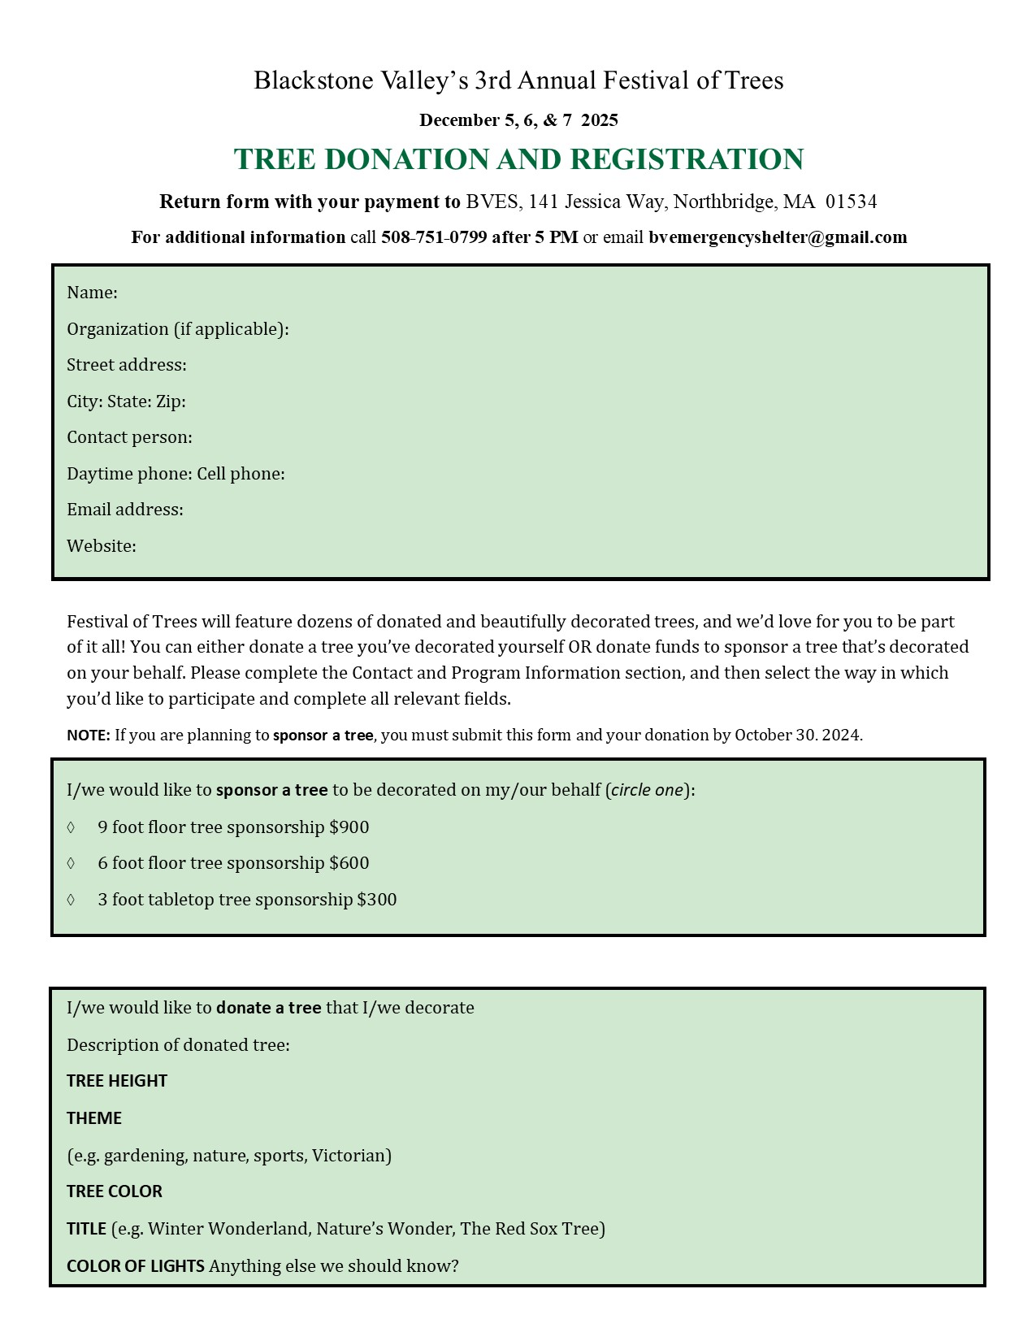
____ We would only like to be a sponsor for $200. Use our information above for marketing purposes. We have filled out the first section with our information.

